The K-L divergence is a measure of how different a specific probability distribution is from a reference distribution. However, it is not a true statistical metric like variation of information which measures the distance between two clustering.

The following is the definition of the K-L divergence for two discrete probability distributions P and Q within the space χ.

The code downloads data on the SPY ETF, calculates daily returns per year and estimates the densities.

> library(quantmod) ; citation("quantmod")

> symetf = c('SPY')

> end<- format(Sys.Date(),"%Y-%m-%d")

> start<-"2006-01-01"

> l = length(symetf)

> dat0 <- lapply(symetf, getSymbols,src="yahoo", from=start, to=end, auto.assign = F,warnings = FALSE,symbol.lookup = F)

> names(dat0[[1]])

[1] "SPY.Open" "SPY.High" "SPY.Low" "SPY.Close" "SPY.Volume" "SPY.Adjusted"

> class((dat0[[1]]))

[1] "xts" "zoo"

> xd <- dat0[[1]]

> head(xd)

SPY.Open SPY.High SPY.Low SPY.Close SPY.Volume SPY.Adjusted

2006-01-03 125.19 127.00 124.39 126.70 73256700 93.39041

2006-01-04 126.86 127.49 126.70 127.30 51899600 93.83268

2006-01-05 127.15 127.59 126.88 127.38 47307500 93.89164

2006-01-06 128.02 128.58 127.36 128.44 62885900 94.67300

2006-01-09 128.42 129.06 128.38 128.77 43527400 94.91622

2006-01-10 128.39 128.98 128.26 128.90 44960800 95.01204

> timee <- index(xd)

> retd <- as.numeric(xd[2:NROW(xd),4])/as.numeric(xd[1:(NROW(xd)-1),4]) -1

> tail(retd)

[1] 0.0056255756 0.0161149572 -0.0005051063 -0.0026529587 0.0040533427 0.0107990769

> # Compute the density per year:

> dens <- density(retd)

> ind1 <- substr(timee[-1], 1, 4)

> dens <- ind2 <- list()

> for(i in 2006:2021){

+ ind2[[i]] <- i == ind1

+ dens[[i]] <- density(100\*retd[ind2[[i]]])

+ }

[1] 4.735643e-03 6.283896e-04 8.321597e-03 2.569309e-03 1.009474e-03 3.180791e-03 -3.943972e-03 -9.317546e-04

[9] -2.719856e-03 -3.974145e-03 3.833500e-03 -1.823706e-02 3.572255e-03 1.028358e-03 8.692295e-04 5.526583e-03

[17] 9.265012e-03 -7.778980e-04 -7.318608e-03 6.980384e-03 -1.160524e-02 -4.964578e-03 2.613455e-03 -8.846722e-03

[25] 9.085113e-03 -1.658498e-03 1.819437e-03 -1.816132e-03 1.060040e-02 3.522481e-03 7.488354e-03 -2.709864e-03

[33] -2.484225e-03 6.070503e-03 -1.469807e-03 2.556570e-03 3.863921e-04 -9.501089e-03 8.890268e-03 -7.725130e-05

[41] -4.638265e-03 -4.582145e-03 -1.560404e-03 2.109901e-03 -6.706238e-03 9.499129e-03 1.866444e-03 1.047886e-02

[49] 4.455385e-03 2.064882e-03 -3.129085e-03 -1.607648e-03 -6.287923e-03 6.096219e-03 -2.070900e-03 7.686265e-04

[57] -1.459204e-03 -6.152922e-03 6.268364e-03 -1.768792e-03 2.311171e-04 -7.702842e-04 6.397919e-03 3.446668e-03

[65] -1.068621e-03 -1.016277e-02 1.544017e-03 -8.478541e-03 1.865718e-03 -1.319041e-03 -3.884935e-04 1.585569e-02

[73] 1.912777e-03 1.374632e-03 1.524365e-04 -1.829890e-03 -4.125040e-03 2.301066e-04 4.831327e-03 3.358025e-03

[81] -8.138792e-03 7.515422e-03 -3.729685e-03 3.590817e-03 8.830717e-03 -1.207388e-03 1.964294e-03 -5.277636e-04

[89] -1.207096e-02 -1.305836e-02 2.011722e-03 -1.467197e-03 -1.902405e-02 -5.045321e-03 7.051731e-03 -7.631794e-03

[97] -7.611187e-03 7.989135e-03 1.236431e-02 5.088875e-03 -1.775983e-02 1.118163e-02 9.567830e-03 2.097444e-03

[105] -1.457362e-02 -2.438680e-03 -7.491499e-03 -8.739949e-04 -3.180930e-03 -1.084962e-02 -1.161380e-02 7.751913e-03

[113] 2.121460e-02 -1.165557e-02 -7.862046e-03 3.396119e-03 7.414022e-03 -4.399672e-03 -1.606701e-04 4.419768e-03

[121] -8.640643e-03 6.779081e-03 2.020038e-02 7.858883e-05 4.085512e-03 -5.712073e-03 2.911797e-03 -6.512877e-03

[129] 1.895561e-03 4.414710e-03 -1.067421e-02 -1.626341e-02 -3.870992e-03 -1.457262e-03 5.107873e-03 1.387433e-02

[137] -6.842231e-03 -7.049627e-03 1.823318e-02 3.565526e-03 1.342160e-03 -9.461720e-04 1.002292e-02 -1.015823e-03

[145] -4.927626e-03 6.759951e-03 2.654560e-03 -1.713137e-03 -2.340055e-03 -3.831102e-03 -3.374939e-03 3.071350e-03

[153] -2.826419e-03 7.873317e-04 1.195818e-02 8.318370e-03 2.544349e-03 5.075775e-03 -4.284926e-03 -7.692307e-05

[161] -2.766677e-03 -8.477266e-04 1.234123e-03 4.776173e-03 1.150111e-03 6.126666e-04 -1.531073e-04 5.970599e-03

[169] 1.902298e-03 -8.809926e-03 -4.597280e-03 2.848087e-03 9.978892e-04 9.815183e-03 4.024596e-03 7.559371e-05

[177] -2.041814e-03 1.363989e-03 -2.497359e-03 5.310652e-03 -4.829824e-03 -3.033245e-03 7.682323e-03 8.303186e-03

[185] 1.197807e-03 -3.738821e-04 -8.227990e-04 -3.743075e-03 2.103990e-03 1.169764e-02 1.927031e-03 -1.257568e-03

[193] 5.925561e-04 1.332504e-03 -1.182842e-03 8.659596e-03 2.568286e-03 1.536932e-03 -3.142298e-03 1.319493e-03

[201] 1.610674e-03 2.192676e-04 4.603954e-03 2.982498e-03 3.408768e-03 3.108009e-03 -6.268879e-03 -7.251541e-04

[209] -1.451636e-04 -6.749344e-03 -5.845536e-04 -1.754686e-03 1.127881e-02 3.838347e-03 2.164368e-03 -5.255280e-03

[217] 4.343031e-04 2.459469e-03 7.504640e-03 2.864984e-03 2.571068e-03 2.848910e-04 5.697337e-04 9.964342e-04

[225] 1.990892e-03 -4.044791e-03 -1.375139e-02 4.334677e-03 1.043013e-02 4.271232e-04 -2.205920e-03 7.630809e-03

[233] 4.317369e-03 -8.456308e-04 -4.372937e-03 1.841839e-03 2.899194e-03 -7.755834e-04 1.058383e-03 8.810884e-03

[241] -5.449965e-03 -2.739912e-03 1.902106e-03 -5.625228e-04 -3.658393e-03 -6.143165e-03 5.896995e-03 6.568675e-03

[249] -2.105031e-03 -4.148878e-03 -1.765287e-03 2.122112e-03 -7.976318e-03 4.625082e-03 -8.498831e-04 3.331580e-03

[257] 4.380465e-03 7.597081e-03 -1.954747e-03 4.196768e-04 -3.356251e-03 1.964459e-03 -3.080815e-03 2.949838e-03

[265] 8.053179e-03 -1.174020e-02 -9.137495e-04 -5.628790e-04 5.209363e-03 6.723209e-03 5.982616e-03 1.383009e-03

[273] 2.762793e-04 2.760994e-04 2.208627e-03 -1.308470e-03 -7.447262e-03 -3.404231e-03 8.435044e-03 6.567102e-03

[281] 1.304869e-03 -4.801577e-04 2.127201e-03 -4.108258e-04 -7.535348e-04 -3.907534e-03 -8.947350e-04 -3.905764e-02

[289] 1.025085e-02 -2.980189e-03 -1.309513e-02 -9.518944e-03 1.710951e-02 -1.002140e-03 8.455195e-03 2.841694e-04

[297] 1.491732e-03 -1.943404e-02 7.450264e-03 1.364173e-03 -6.739815e-03 1.205514e-02 5.492183e-03 1.645735e-02

[305] -7.676740e-04 1.466727e-03 -1.325071e-03 -2.374274e-03 -7.279812e-03 1.057636e-03 2.113052e-04 1.126789e-03

[313] 1.076251e-02 1.113536e-03 2.711150e-03 1.386557e-03 1.176952e-03 -4.079918e-03 4.443827e-03 4.562443e-03

[321] 9.496215e-03 2.658480e-03 1.223795e-03 -2.716643e-04 9.441004e-03 -3.767979e-03 4.052209e-04 9.181752e-03

[329] 1.137263e-03 -8.018377e-04 -8.292690e-03 2.562580e-03 5.851853e-03 5.416698e-03 3.791101e-03 1.987742e-04

[337] -1.324922e-03 2.719761e-03 -1.045251e-02 8.557287e-03 -2.187472e-03 2.657809e-04 6.840665e-03 -1.978912e-03

[345] 8.724336e-03 -5.241908e-04 -7.866462e-04 1.312426e-04 -9.052768e-03 4.170555e-03 3.625836e-03 8.144975e-03

[353] -1.042409e-03 4.956920e-03 1.298287e-04 -3.958475e-03 -1.074994e-02 -1.804525e-02 1.301131e-02 1.721465e-03

[361] -1.090555e-02 1.496829e-02 6.386214e-03 1.373845e-03 -1.175985e-03 2.485480e-03 -1.389708e-02 5.557741e-03

[369] -9.409087e-03 -4.782471e-03 -1.027838e-02 1.422888e-02 -1.329056e-04 3.324112e-04 9.040750e-03 3.623447e-03

[377] -1.050302e-03 5.256953e-03 7.844817e-04 -1.423911e-02 7.089895e-03 1.579047e-02 2.979513e-03 -1.291831e-04

[385] -5.167086e-04 -1.809363e-03 3.884288e-03 -1.012450e-02 3.061896e-03 -1.734103e-02 2.048896e-03 -2.367916e-02

[393] -1.965953e-02 1.564333e-02 -1.126343e-02 4.872303e-03 7.990255e-03 -2.574528e-02 1.675942e-02 1.066956e-02

[401] 1.394057e-02 -2.963360e-02 -4.677020e-03 3.593317e-03 -1.528611e-02 -1.377527e-02 7.515691e-03 1.836735e-02

[409] -4.837813e-04 2.004936e-03 1.186781e-02 -8.863962e-04 1.235325e-02 -9.303613e-03 -2.198024e-02 1.962143e-02

[417] -2.661383e-03 9.852905e-03 1.009558e-02 -8.653132e-03 2.300643e-03 -1.390669e-02 -1.916985e-03 1.166069e-02

[425] 2.576378e-03 7.033266e-03 -6.722181e-05 -5.372653e-03 2.943957e-02 5.903148e-03 -7.042267e-03 -2.035711e-03

[433] -1.842462e-03 -1.977737e-03 5.284385e-03 5.913621e-03 -3.331335e-03 1.127278e-02 -1.361030e-03 -2.011792e-03

[441] 1.560704e-03 1.188159e-02 -5.325646e-03 9.418088e-03 -1.661522e-03 -4.800922e-03 5.531620e-03 -8.443722e-03

[449] -7.934946e-03 3.056321e-03 -3.630457e-03 -2.615657e-02 5.812755e-03 8.104172e-03 -1.845012e-03 2.376551e-03

[457] 1.172286e-02 3.319945e-03 -6.942237e-03 1.038806e-02 -2.340766e-02 1.125591e-03 -7.605781e-03 1.346221e-02

[465] -2.735584e-02 -5.070651e-03 -1.372659e-02 -9.921469e-03 3.048020e-02 -2.768801e-03 -1.442409e-02 1.717741e-03

[473] -1.392412e-02 6.121341e-03 -2.046464e-02 1.729258e-02 -2.206347e-02 1.149351e-02 3.198427e-02 3.397539e-04

[481] 1.005579e-02 -6.592298e-03 -8.938191e-03 1.673953e-02 1.431358e-02 -1.987412e-04 7.752952e-03 -2.741977e-02

[489] 9.870806e-03 -2.075363e-03 -1.267946e-02 -1.426915e-02 5.583497e-03 0.000000e+00 6.306539e-03 9.059959e-03

[497] 7.425849e-03 2.144388e-03 -1.257108e-02 -2.505553e-03 -7.399837e-03 -8.754626e-03 -4.829366e-04 -2.450644e-02

[505] -8.491685e-04 -1.614844e-02 1.051034e-02 6.554093e-03 -8.068505e-03 8.062826e-03 -2.201303e-02 -8.612593e-03

[513] -2.591621e-02 -1.026752e-02 -1.014688e-02 2.402081e-02 8.441685e-03 -1.444560e-02 1.653647e-02 4.954148e-03

[521] -7.357810e-03 1.823431e-02 1.608799e-02 -1.260922e-02 -2.677407e-02 -8.051905e-03 6.613980e-03 -6.421161e-03

[529] 5.110040e-03 9.271065e-03 1.022291e-02 -8.799568e-03 -2.219353e-04 2.811936e-03 2.951549e-03 -8.313751e-03

[537] 6.157742e-03 1.260881e-02 7.500175e-03 -1.011853e-03 -9.767081e-03 -2.228383e-02 -2.391324e-03 -3.820187e-03

[545] 6.316242e-03 -2.069793e-02 -1.030056e-02 -1.318331e-02 3.593755e-02 -9.351470e-03 2.207620e-03 -1.549558e-02

[553] -1.010723e-02 4.154327e-02 -2.476987e-02 1.350518e-02 1.998788e-02 9.650015e-04 -1.223588e-02 -3.153138e-03

[561] -9.564724e-03 3.497879e-03 3.515951e-02 6.587805e-04 2.487169e-03 -1.094527e-03 5.114179e-04 -1.022196e-03

[569] -7.235820e-03 1.398822e-03 -1.940890e-02 -3.373909e-03 2.332145e-03 2.709397e-02 1.461432e-03 1.043410e-02

[577] 5.055387e-04 -4.402750e-03 -1.594904e-03 4.356709e-03 9.253896e-03 2.148925e-04 -3.939003e-03 -5.895938e-03

[585] 2.068567e-02 2.763606e-03 -4.805265e-03 8.662934e-03 -1.781062e-02 -2.580275e-03 -1.868425e-03 1.123120e-02

[593] 1.423110e-04 2.064408e-03 1.250263e-02 9.121238e-04 2.733766e-03 -8.109081e-03 -1.691447e-02 1.433078e-04

[601] -1.340403e-02 7.410673e-03 4.615599e-03 5.025104e-03 2.500043e-03 -1.033140e-02 -5.831519e-03 -5.068579e-04

[609] 1.999707e-02 -3.189378e-02 2.421322e-03 -4.977258e-03 -1.471237e-02 3.807638e-03 1.264408e-02 5.876019e-04

[617] -4.844667e-03 -9.736719e-03 1.266279e-03 -2.112778e-02 -9.880301e-04 -1.977900e-03 4.725939e-03 -2.716032e-02

[625] -5.458918e-03 3.528613e-03 3.125504e-03 -1.713666e-02 1.030258e-03 -1.021298e-02 1.775717e-02 -1.925493e-02

[633] 4.086882e-03 -1.165209e-02 -9.043888e-03 -1.409716e-02 2.454749e-02 1.000321e-02 6.230080e-03 5.556437e-04

[641] 1.134470e-02 5.412574e-03 -2.075366e-02 -2.390168e-04 -1.466372e-02 2.135231e-02 1.781755e-02 -1.322646e-02

[649] -5.282646e-03 -9.273985e-03 2.696218e-02 4.440573e-03 -1.489173e-02 1.858116e-02 1.035798e-02 -1.040472e-02

[657] -6.030143e-03 7.544419e-03 4.863402e-03 -1.367442e-02 -1.090428e-02 4.646067e-03 1.724416e-03 1.447567e-02

[665] -2.028536e-02 2.912943e-03 9.733935e-03 1.212778e-02 -1.075358e-02 -6.211624e-03 -8.594500e-04 -3.010633e-02

[673] 3.144393e-03 2.065584e-02 -2.968735e-02 4.057783e-03 1.446816e-02 4.621098e-03 -4.758506e-02 1.673746e-02

[681] -4.496312e-02 2.967155e-02 3.373035e-02 -2.263942e-02 -2.275159e-02 3.205373e-03 1.563946e-02 4.967050e-04

[689] -7.836161e-02 4.138985e-02 6.035003e-04 -3.627434e-02 -1.350024e-02 -5.093343e-02 -4.478611e-02 -2.519241e-02

[697] -6.983904e-02 -2.425576e-02 1.451977e-01 -1.480020e-02 -9.844768e-02 4.165741e-02 -5.972038e-03 6.007938e-02

[705] -2.985525e-02 -5.445443e-02 1.158432e-02 -5.071437e-02 -3.550096e-02 1.168553e-01 -7.252560e-03 3.459391e-02

[713] 5.503624e-03 2.891655e-03 3.398211e-02 -4.202770e-02 -5.541117e-02 3.301783e-02 -1.310467e-02 -3.087553e-02

[721] -4.400130e-02 6.233976e-02 -4.990671e-02 -1.327640e-02 1.883703e-02 -6.407903e-02 -7.423317e-02 5.394301e-02

[729] 6.929077e-02 7.409209e-03 3.864110e-02 1.258846e-02 -8.857804e-02 3.848491e-02 2.404132e-02 -2.313327e-02

[737] 3.083232e-02 3.491414e-02 -1.648352e-02 6.815654e-03 -2.408167e-02 1.193991e-02 -1.393413e-02 4.706549e-02

[745] -9.686537e-03 -1.868334e-02 -1.231940e-02 -1.281329e-02 -1.033763e-02 5.803157e-03 5.769674e-03 -2.868288e-03

[753] 2.370265e-02 1.427444e-02 3.014186e-02 -1.183315e-03 6.677469e-03 -2.995617e-02 4.080766e-03 -2.141921e-02

[761] -2.402064e-02 1.840184e-03 -3.145446e-02 3.555648e-04 7.819858e-03 -5.278625e-02 4.319229e-02 -1.546702e-02

[769] 4.350465e-03 6.858368e-03 1.015773e-02 3.383414e-02 -3.249795e-02 -2.034300e-02 -3.018230e-03 1.404694e-02

[777] -4.896059e-03 1.488057e-02 2.849714e-02 1.379570e-03 -4.580938e-02 5.895765e-03 7.177751e-04 -1.075785e-02

[785] -4.277430e-02 -2.398409e-03 -1.075540e-02 -9.721182e-03 -3.577882e-02 3.791026e-02 -7.872999e-03 -1.626122e-02

[793] -2.234862e-02 -4.504263e-02 -7.507054e-03 2.369064e-02 -4.084762e-02 1.744113e-03 -1.175271e-02 5.960941e-02

[801] 6.512415e-03 3.937226e-02 7.814517e-03 -3.022671e-03 3.058264e-02 2.238424e-02 -1.238581e-02 -2.824934e-02

[809] 7.182899e-02 -1.970327e-02 1.054589e-02 2.038065e-02 -1.804837e-02 -3.455459e-02 9.265084e-03 1.936621e-02

[817] 2.923763e-02 9.948484e-03 -7.832945e-03 -2.332531e-02 1.077767e-02 3.974311e-02 2.331197e-04 -1.724343e-02

[825] 1.066985e-02 1.466276e-02 6.705225e-03 -4.191550e-02 1.953731e-02 -6.113297e-03 9.817861e-03 1.511071e-02

[833] -9.462358e-03 -3.145340e-03 2.126912e-02 3.432773e-04 5.376356e-03 3.401978e-02 -3.411059e-03 1.733465e-02

[841] -1.389188e-02 2.333262e-02 -1.871376e-02 -2.959196e-03 -2.517314e-02 8.570162e-03 -8.161930e-03 2.840721e-02

[849] -1.205744e-03 -6.694480e-03 -1.436309e-02 -2.129829e-03 2.561229e-02 -1.785329e-02 1.394000e-02 1.770789e-02

[857] 2.420834e-02 8.441596e-04 -1.265151e-02 9.396658e-03 2.116154e-04 -4.124791e-03 5.097653e-03 -2.535894e-03

[865] 4.449131e-03 2.742059e-03 -2.292806e-02 -1.356300e-02 -9.820602e-04 7.318383e-03 -1.951854e-03 -2.998698e-02

[873] 7.840390e-04 8.617851e-03 2.174877e-02 -2.606494e-03 9.364123e-03 -8.090615e-03 4.132735e-03 -2.729345e-02

[881] -1.112905e-04 -1.937645e-02 -6.813309e-04 1.931795e-03 -2.381751e-03 2.432923e-02 5.660411e-03 2.924623e-02

[889] -1.608417e-03 1.095474e-02 1.062361e-02 4.625281e-03 -2.092393e-04 2.208269e-02 4.095781e-03 2.957373e-03

[897] -4.677163e-03 -2.451701e-03 1.044543e-02 1.418871e-03 1.649635e-02 2.588560e-03 -2.879772e-03 -5.178817e-03

[905] 1.311441e-02 -2.075089e-03 -1.247643e-02 1.072897e-02 7.638859e-03 -7.679423e-03 -2.460565e-02 7.934066e-03

[913] 8.779928e-03 1.030411e-02 1.960593e-02 -9.713509e-05 1.942551e-03 9.687863e-05 2.229369e-03 -1.934719e-04

[921] -8.899188e-03 -2.205741e-02 -3.792385e-03 8.314987e-03 1.400890e-02 8.622418e-03 7.674383e-03 1.021882e-02

[929] -1.908961e-04 4.867825e-03 4.179350e-03 1.513431e-02 -1.490831e-03 -4.106038e-03 -2.530022e-03 5.824359e-03

[937] -8.312319e-03 -1.101901e-02 -5.332873e-03 1.790333e-02 -3.009782e-03 -3.867962e-03 -2.481291e-02 -4.661581e-03

[945] 1.492828e-02 1.432422e-02 2.748564e-03 7.655936e-03 6.096998e-03 3.915700e-03 -2.043100e-03 1.721570e-02

[953] 3.659327e-03 -7.474250e-03 8.265240e-03 -5.282831e-03 -8.973501e-03 1.016353e-02 -1.143328e-02 -1.082530e-02

[961] -4.583350e-03 -1.888737e-02 2.145386e-02 -2.897331e-02 7.338760e-03 3.163363e-03 2.579990e-03 1.839497e-02

[969] 2.620487e-03 2.277610e-02 1.824952e-04 5.110010e-03 -1.016798e-02 5.411391e-03 1.450462e-02 1.168933e-03

[977] -6.286959e-04 -1.303134e-02 -3.551266e-03 1.270218e-02 1.534001e-03 3.513821e-03 -1.625065e-02 3.376855e-03

[985] 1.237039e-02 -4.492632e-04 -7.820252e-03 5.707601e-03 -1.531448e-03 -1.109703e-02 3.740498e-03 5.635357e-03

[993] 4.248030e-03 6.840086e-03 -4.648297e-03 1.526709e-03 -1.201576e-02 2.722726e-04 1.016244e-02 3.592931e-03

[ reached getOption("max.print") -- omitted 2838 entries ]

> plot(retd)

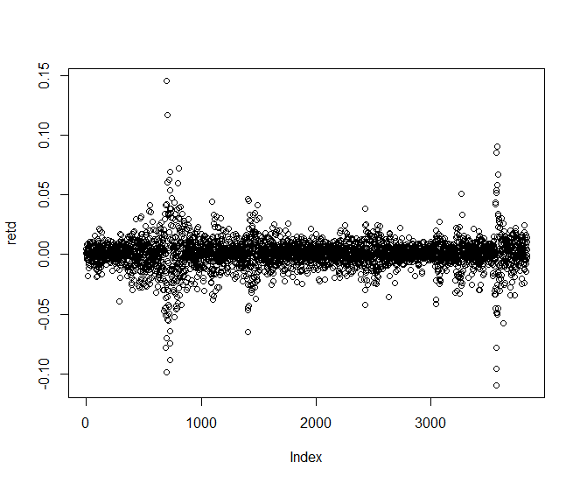

> plot(density(retd))

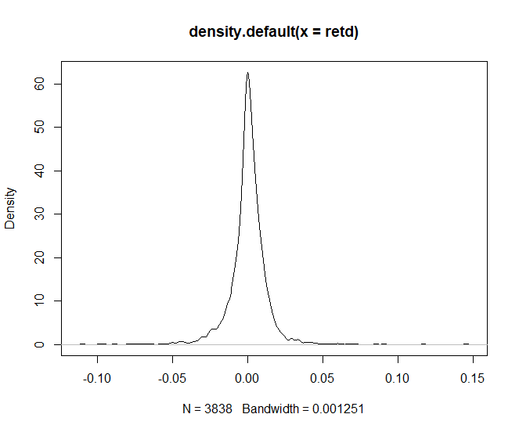

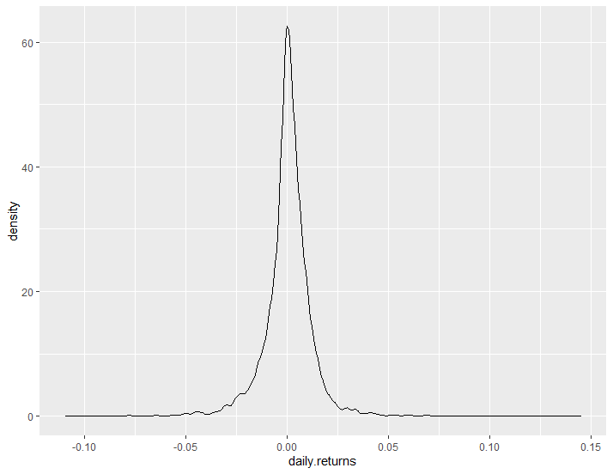

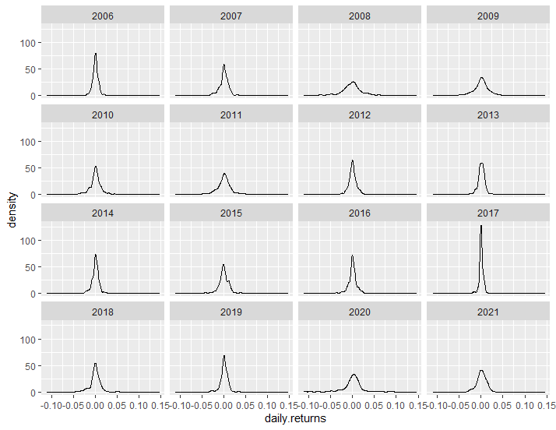

For discrete probability distributions P and Q, the Kullback–Leibler divergence from Q to P is defined as:

\[{\displaystyle D_{\mathrm {KL} }(P\|Q)=-\sum _{i}P(i)\,\log {\frac {Q(i)}{P(i)}}}.\]

which is equivalent to

\[{\displaystyle D_{\mathrm {KL} }(P\|Q)=\sum _{i}P(i)\,\log {\frac {P(i)}{Q(i)}}}.\]

In a good understanding, there are two distributions, Q and P. The distribution of say the daily returns during 2021, let’s call it Q, and the overall distribution of daily return up until (excluding) 2021, let’s call it P.

The measure is a sum. It is easy to sum over i, which you can think.

The Q(i) is the density (an estimate of the density in practice) of the 2021 distribution at point i. The P(i) is the density (an estimate of the density in practice) of the overall distribution at point i. Note to self: at the same point i.

The log operator is standard in information theory, which is the origin of the KL Divergence measure.

The P(i) is key to understand this measure. Let’s think about it as a weighting scheme. When i= roughly zero, the P(0) (estimate of the) density is quite high, so if there is a big difference around that point between the two distributions we give it a high weight in the overall measure. However, if we look at i= roughly 5, then the (estimate of the) P(5) density is quite low, so there can be a large difference between those distributions there without a large impact on the Kullback – Leibler measure. Only if you insist (as you do undoubtedly), another way to think about it is as an expectation of that ratio according to the P distribution.

From that last point, one can understand that there must be a base-distribution call it. There is no analogy with scalars, there is no base-point from which one measure the distance between the two points. It is clearly noted that the Kullback – Leibler measure is actually not a distance. Distance has few formal conditions. Symmetry is an important condition, and it does not hold here. If we interchange Q and P, such that Q is the overall distribution instead of the 2021 distribution, we would get a different number. This explains the use of the word divergence, rather than simply calling it distance.

Let’s look at the two distributions jointly, the distribution of daily returns up to 2021, and the distribution of daily return during 2021 (up to now). I care about the shape, so I don’t mind what is on the y-axis.

Now lets compute the divergence between those two. We can use the LaplacesDemon package in R.

> library("LaplacesDemon") # Install if not already

Warning message:

package ‘LaplacesDemon’ was built under R version 4.0.4

> citation("LaplacesDemon")

> tmpind <- which(index(dat0[[1]])=="2016-12-30")

> density\_tot <- density(100\*retd[1:tmpind])

> KL <- KLD(density\_tot$y, dens[[2017]]$y)

> plot(KL$KLD.py.px)

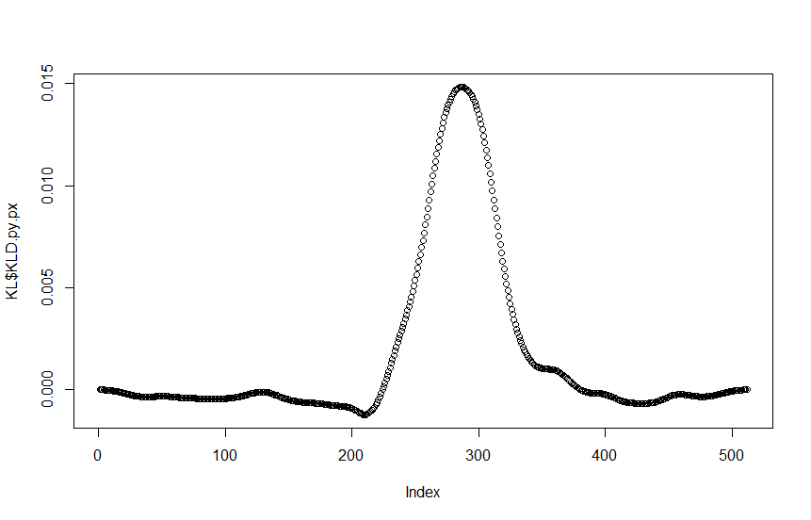

In this case study, we have 500 points roughly. We can sum up those 500 points to get a KL summary measure for the divergence between those two distributions. This measure can be used as a quantification, but the chart is also useful when you want to know what and where exactly is the origin of the divergence. Also, we have some negative values which is fine. Think about the squared error metric, when you square an error smaller than 1 you make it smaller. Here when the ratio is below 1, it contributes negatively to the overall divergence. The sum however would never be negative. If the two distributions are the same, then the sum should be zero. Although in practice it would not be because of estimation noise.

.